 

# COLLEGE CHATBOT

## A PROJECT REPORT

**Submitted by**

|  |  |
| --- | --- |
| **RAMASAMY.A** | **950820104039** |
| **SHUNMUGA RAJESHWARAN.S** | **950820104044** |
| **ARUL RAJAVEL.S** | **950820104302** |
| **KAMESH.R** | **950820104303** |

## BACHELOR OF ENGINEERING

*in*

COMPUTER SCIENCE AND ENGINEERING

**GOVERNMENT COLLEGE OF ENGINEERING, TIRUNELVELI**

## ANNA UNIVERSITY: CHENNAI 600 025

**MAY 2023**

# BONAFIDE CERTIFICATE

Certified that this project **“COLLEGE CHATBOT”** is the bonafide work of **“RAMASAMY.A (950820104039), SHUNMUGA RAJESHWARAN.S (950820104044), ARUL RAJAVEL.S (950820104302), KAMESH.R (950820104303)”** who carried out the project work under my supervision.

|  |  |
| --- | --- |
| **SIGNATURE,** | **SIGNATURE,** |
| **Dr. G. TAMILPAVAI, M.E., Ph.D.,**  **PROFESSOR & HEAD OF THE DEPARTMENT,**  Dept. of Computer Science and Engg.  Government College of Engineering, Tirunelveli-627007. | **MRS. G. SONA M.E.,**  **ASSISTANT PROFESSOR,**  Dept. of Computer Science and Engg.  Government College of Engineering, Tirunelveli-627007. |

Submitted for project **Viva- Voce** held at Government College of Engineering Tirunelveli held on ____________________

# Internal Examiner External Examiner

**ACKNOWLEDGEMENT**

Our sincere thanks and profound sense of gratitude goes to our college Principal

**Dr.** **SIDDHARTHAN M.E., Ph.D.,** for permitting us to do this project successfully.

With great pride and immense pleasure, we express our deep sense of gratitude and profound thanks to **Dr. G. TAMILPAVAI, M.E., Ph.D.,** Professor and Head of Computer Science and Engineering, for encouraging us to undertake this project.

We are grateful to our internal project guide, **Mrs.** **G. SONA, M.E.,** Assistant Professor in Department of Computer Science and Engineering who has been our constant source of inspiration giving us kind advice, encouragement and guiding us throughout the project.

With great pride and pleasure, we express our sincere thanks to our faculty advisor,

**Dr. M. MAHIL, M.E., Ph.D.,** Assistant Professor, Department of Computer Science and Engineering for undertaking this project and for her profound and valuable insights and comments on our project.

We also express our special thanks to all the teaching and non-teaching staff members for their help in completing our project.

Finally, we thank our friends for their encouragement and help during the execution of our project.

# ABSTRACT

The College Chatbot project aims to improve the students experience by leveraging the power of artificial intelligence (AI) to provide timely and relevant assistance. In today’s fast -paced world, students often face various challenges, such as accessing information, navigating campus resources, and receiving personalized guidance. This project addresses these issues by developing a chatbot powered by Natural Language Processing (NLP) and machine learning algorithms. It utilizes NLP techniques to understand and interpret user queries, enabling it to provide accurate responses and valuable recommendations. . Using AI algorithms, the chatbot will continuously learn and improve its responses based on user interactions, ensuring accurate and relevant information is delivered.

**TABLE CONTENTS**

|  |  |  |
| --- | --- | --- |
|  |  |  |
| **CHAPTER NO** | **TITLE** | **PAGE NO** |
|  | **ACKNOWLEDGEMENT** | **iii** |
|  | **ABSTRACT** | **iv** |
| **1.** | **INTRODUCTION** | **1** |
| **2.** | **LITERATURE SURVEY** | **4** |
| **3.** | **PROBLEM STATEMENT** | **7** |
|  | 3.1 EXISTING SYSTEM | 7 |
|  | 3.2 PROPOSED SYSTEM | 9 |
|  | 3.3 BLOCK DIAGRAM | 10 |
|  | 3.4 WORKING PRINCIPLE | 10 |
|  | 3.5 WORK FLOW | 12 |
| **4.** | **REQUIREMENT SPECIFICATION** | **13** |
|  | 4.1 INTRODUCTION | 13 |
|  | 4.2 SOFTWARE REQUIREMENTS | 13 |
|  | 4.3 APPLICATIONS | 13 |
| **5.** | **METHODOLOGY** | **14** |
|  | 5.1 LIST OF MODULES | 14 |
|  | 5.1.1 DATA COLLECTION | 14 |
|  | 5.1.2 DATA PREPROCESSING | 14 |
|  | 5.1.3 DESIGN CONVERSATION FLOW | 15 |
|  | 5.1.4 DEVELOP NLP MODELS | 15 |
|  | 5.1.5 MODEL TRAINING | 15 |
|  |  |  |
|  | 5.1.6 INTENT RECOGNITION AND  ENTITY EXTRACTION | 15 |
|  | 5.1.7 IMPLEMENT DIALOG MANAGEMENT | 16 |
|  | 5.1.8 INTEGRATION AND EXTRNAL SERVICES | 16 |
|  | 5.1.9 TESTING AND INTEGRATION | 16 |
|  | 5.2 ALGORITHM | **17** |
|  | 5.3 STEPS INVOLVED IN TRAINING | **18** |
| **6.** | **RESULTS** | **19** |
| **7.** | **CONCLUSION** | **21** |
| **8.** | **REFERENCES** | **22** |
|  |  |  |

**LIST OF FIGURES**

|  |  |  |
| --- | --- | --- |
| **FIGURE NO** | **FIGURE NAME** | **PAGE NO** |
| 3.1 | Block Diagram | 10 |
| 3.2 | Work Flow Diagram | 12 |
| 6.1 | Training Data | 19 |
| 6.2 | Data format | 19 |
| 6.3 | Similarity | 20 |
| 6.4 | Home Page | 20 |

**LIST OF ABBREVIATIONS**

|  |  |
| --- | --- |
| **ABREVIATION** | **EXPLANATION** |
| AI | Artificial Intelligence |
| NLP | Natural Language Processing |
| IDE | Integrated Development Environment |
| JSON | Java Script Object Notation |
| API | Application Programming Interface |
| PII | Personally Identifiable Information |
|  |  |
|  |  |

**CHAPTER - 1**

## INTRODUCTION

The College Chatbot project introduces an AI-powered chatbot for college students, aiming to enhance the student experience and provide timely assistance. Leveraging Natural Language Processing (NLP) and machine learning, the chatbot offers real-time information on courses, schedules, campus resources, and personalized recommendations. By mimicking natural conversations, the chatbot streamlines communication and improves accessibility. This report provides an analysis of the development process, system architecture, and potential benefits of the College Chatbot in transforming student interactions and fostering a connected college experience.

The purpose of this project is to design and implement a college chatbot that leverages NLP and AI techniques to provide comprehensive and tailored support to college students. The chatbot will be capable of understanding and interpreting natural language inputs from students, enabling efficient communication and prompt problem-solving. By harnessing the power of AI algorithms, the chatbot will continuously learn and improve its responses, ensuring accurate and relevant information is delivered to the students.

The college chatbot will be designed to address a wide range of student needs, including academic queries, administrative tasks, and general information. Students will be able to seek assistance related to course registration, academic planning, timetable management, campus resources, campus events, program requirements, and career advice, among other areas. The chatbot will act as a reliable and accessible virtual assistant, available round-the-clock to address student concerns and provide guidance.

To develop an effective chatbot, a diverse dataset of student queries will be collected and analyzed. This dataset will serve as the foundation for training the NLP model, enabling the chatbot to understand and interpret various types of student queries accurately. Integration with existing college systems and databases will be crucial to accessing real-time data, ensuring that the chatbot provides up-to-date information and reflects any changes in college policies or procedures.

The interface of the chatbot will be designed to be user-friendly and intuitive, allowing students to engage in natural and conversational interactions. The chatbot will be programmed to handle complex queries and provide appropriate responses, taking into account the context and the specific needs of the students. The aim is to create an engaging and seamless user experience that closely mimics human-like conversation.

Evaluation of the chatbot's performance will be an ongoing process throughout the development phase. User feedback and analysis of system logs will provide valuable insights into the strengths and weaknesses of the chatbot, enabling continuous optimization and improvement. Ethical considerations, such as data privacy and security, will be given utmost importance to ensure that student information is handled responsibly and in compliance with privacy regulations.

By implementing an NLP and AI-based college chatbot, the project aims to revolutionize the way colleges provide support services to their students. The chatbot's ability to understand and respond to student queries accurately will reduce the need for manual intervention, thereby enhancing administrative efficiency. Moreover, the chatbot's round-the-clock availability will ensure that students receive timely and reliable support, leading to an improved overall student experience.

In the subsequent sections of this project report, we will delve into the technical aspects of designing and developing the college chatbot, including the methodology, implementation details, evaluation metrics, and results. We will also discuss the potential impact of the chatbot on student support services and highlight the ethical considerations associated with its deployment.

As educational institutions strive to provide modern and innovative learning environments, integrating AI-powered technologies becomes imperative. The chatbot not only enhances student support but also contributes to the overall digital ecosystem of the college. By adopting this technology, colleges can position themselves as forward-thinking institutions, embracing AI advancements to meet the evolving needs of their students. This project represents a significant step towards the integration of cutting-edge technologies into the college infrastructure, fostering a more efficient and student-centric educational experience.

# CHAPTER 2

## LITERATURE SURVEY

1. **TITLE:** **NLP Based Chatbot for Multiple Restaurants**

**AUTHORS: Rishma Garg; Riya Riya; Sahil Thakur; Nancy Tyagi; Kasunuru**

**Nawaz Basha; Dinesh Vij.**

**PUBLISHED IN: IEEE Paper**

**PUBLISHED ON:** [**10-11 December 2021**](https://link.springer.com/article/10.1007/s43576-022-00073-y#article-info)

Errand arranged chatbots can be utilized to robotize a specific task, for example, finding a restaurant and reserving a spot. Carrying out such a conversational framework can be difficult, requiring space information and handmade principle Restaurant chatbot is an automated system for carrying out day to day work in a restaurant such as ordering, reservations, FAQs at reception, and many more tasks which are not that much important but take much time of the receptionist while working. Chatbot is a system backed by an Artificial Intelligence technology to learn, adapt and work according to the surrounding environment. The main focus of this proposal was to assess the chance of utilizing a neural organization based model to make a start to finish teachable chatbot that can mechanize an eatery reservation administration. The reason for this review was to investigate clients’ insights and practices when utilizing chatbots in cafe takeout orders. Based on the social presence hypothesis, this review led a lab examination to look at and think about three requesting techniques in speedy help and full-administration restaurant.

2**. TITLE: AI And Web-Based Interactive College Enquiry Chatbot**

**AUTHORS: Rohan Parkar; Yash Payare; Keyur Mithari; Jitesh Nambiar; Jaya Gupta**

**PUBLISHED IN: IEEE Paper**

**PUBLISHED ON: 23 August 2021**

AI and web-based interactive College Enquiry Chatbot is a straightforward web application that aims to supply knowledge regarding college. The chatbot created here may be a web-based application that uses tongue Processing Libraries and AI terminology to possess conversations with humans. “Eliza” and “Clever bot” are several online applications that are created within the past. The College Enquiry Chatbot will engage in friendly conversations, respond to the course and college information, provide a link to the tutorial calendar, and answer frequently asked questions, among other things. This project is specialized in creating a chatbot to be employed by students to urge their queries responded to easily from the college website. A chatbot may be a program that may do real conversations with textual and/or auditory methods. Using AI, chatbots can simulate human conversations. Humans respond to others depending on their mood and emotions. Whereas chatbots are bound by some rules, resulting in them treating a customer most politely and perfectly. Students can ask questions to the chatbot at any time of the day and get a reply very quickly. At any time of day, chatbots can have simultaneous conversations with thousands of people. A chatbot can work 24x7 without getting tired. It is subjected to minimal errors thus increasing productivity.

3. **TITLE:** **College Enquiry Chatbot Using Knowledge in Database**

**AUTHORS: Harsha P. Pawar**

**PUBLISHED IN: ijraset (International Journal for Research in Applied Science and Engineering Technology)**

**PUBLISHED ON:** [**30**](https://link.springer.com/article/10.1007/s12652-023-04530-y#article-info) **April 2018**

The College Enquiry Chatbot project is built using Microsoft Bot Builder, LUIS.ai and MongoDB for database[3]. This System is a web application which provides answer to the query of the student[2]. Students just have to query to the bot and bot will answer to student question[1]. Students can ask questions using any English text format[1]. There is no specific format the user has to follow[2]. The System uses built in Artificial Intelligence to answer the query provided by LUIS.ai. The system replies using an effective Graphical User Interface which implies that as if a real person is talking to the user[4]. First, bot will send query to the LUIS.ai. LUIS.ai will send its response to bot after that bot will fetch value from database and then give answer to user question[

## CHAPTER 3 PROBLEM STATEMENT

## EXISTING SYSTEM:

The Existing college chatbot systems were early implementations of automated support for college students. These systems were typically rule-based and lacked the advanced NLP and AI capabilities seen in more recent iterations existing college chatbots struggled to maintain contextual awareness during conversations. Due to their limited capabilities, the existing chatbot systems often provided suboptimal user experiences. Users may have encountered frequent misunderstandings, irrelevant responses, or difficulty in navigating the conversation flow.

**DRAWBACKS OF EXISTING SYSTEM:**

**Limited Understanding and Contextual Awareness:** Existing college chatbots often struggle to understand complex queries or requests that deviate from their pre-programmed responses. They may fail to grasp the context of the conversation or provide accurate and relevant information. These limitations can lead to frustration for students who seek specific and nuanced assistance.

**Lack of Personalization:** Many college chatbots provide generic responses that may not be tailored to individual students' needs. These chatbots often lack the ability to adapt and learn from user interactions, resulting in a standardized user experience that may not adequately address individual preferences or requirements.

**Inability to Handle Ambiguity:** College chatbots may struggle to handle ambiguous queries or ambiguous terms, which can result in inaccurate responses or confusion. Natural language is inherently complex, and existing chatbot systems may not possess the necessary sophistication to disambiguate queries effectively.

**Limited Domain Knowledge:** College chatbots heavily rely on pre-defined knowledge bases or databases, which may not be comprehensive or up-to-date. If the chatbot lacks access to the latest information, it may provide outdated or incorrect responses, leading to inaccurate guidance for students.

**Lack of Emotional Intelligence:** College life can be stressful, and students may require emotional support. Existing chatbots often lack emotional intelligence and fail to provide empathetic or compassionate responses. This limitation can hinder their ability to effectively address students' emotional needs.

**Integration Challenges:** Integrating college chatbots with existing systems, databases, and APIs can be challenging. Incompatibility issues, data synchronization problems, and security concerns can arise during the integration process, hampering the chatbot's functionality and reliability.

## 

## 3.2.PROPOSED SYSTEM:

The proposed system for the College Chatbot project is an AI-powered chatbot designed to enhance the student experience and provide comprehensive support. The chatbot leverages Natural Language Processing (NLP) and machine learning algorithms to understand user queries and provide accurate and personalized responses. The chatbot offers 24/7 availability, faster response times, and the ability to deliver tailored recommendations, streamlining communication and improving accessibility for students .

**3.3 BLOCK DIAGRAM:**

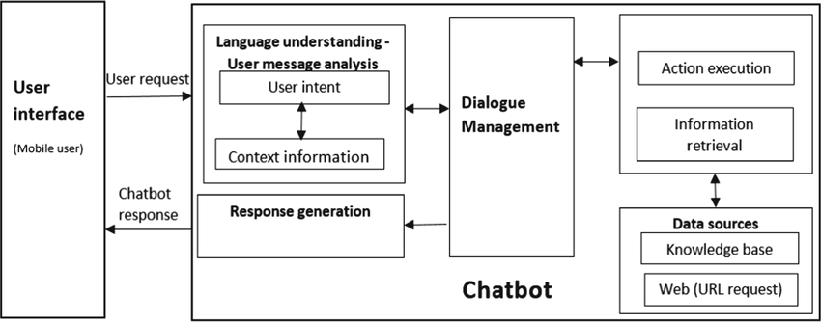

Figure:3.1

**3.4 WORKING PRINCIPLE:**

1. **User Input Processing:** The chatbot receives user input, which can be in the form of text or speech. It then preprocesses the input by

tokenizing it into individual words or phrases, removing any irrelevant or noisy information, and performing any necessary text cleaning or normalization.

1. **Natural Language Processing (NLP) Analysis:** The preprocessed

input is passed through various NLP techniques to extract meaningful information. These techniques can include part-of-speech tagging,named entity recognition, sentiment analysis, and syntactic parsing.These analyses help in understanding the user's intent, identifying important entities, and determining the sentiment or context of the input.

1. **Intent Recognition:** Based on the NLP analysis, the chatbot

categorizes the user's input into predefined intents or purposes. This step involves training a machine learning model or using rule-based algorithms to classify the input. Intents represent the user's goals or the type of action the chatbot needs to perform in response.

1. **Response Generation:** Once the intent is recognized, the chatbot generates an appropriate response based on the user's input and the

identified intent. This step involves using NLP techniques to construct meaningful and contextually relevant responses. It can include techniques like text generation, template-based responses, or retrieving information from a knowledge base or external APIs.

1. **Context Management:** To maintain a coherent conversation, the

chatbot keeps track of the context of the conversation. It remembers previous interactions and uses that information to understand and respond appropriately to subsequent user input. This helps in providing personalized and contextual responses to the user.

1. **Integration with APIs or Databases:** In some cases,chatbot may need to integrate with external APIs or databases to fetch or provide information. It can include accessing external services for weather

data, retrieving product information from an e-commerce database, or querying a knowledge base for specific answers.

1. **Error Handling:** The chatbot handles situations where user input is unclear, ambiguous, or not recognized by providing appropriate error messages or prompts for clarification. It can ask the user to rephrase the input or provide more specific details to ensure accurate

understanding.

1. **User Experience:** The chatbot is designed to provide a user-friendly and intuitive interface for interacting with users. It can include features like natural language understanding, error recovery mechanisms,

prompts for user guidance, and a conversational flow that mimics human conversation.

**3.5 WORKFLOW:**

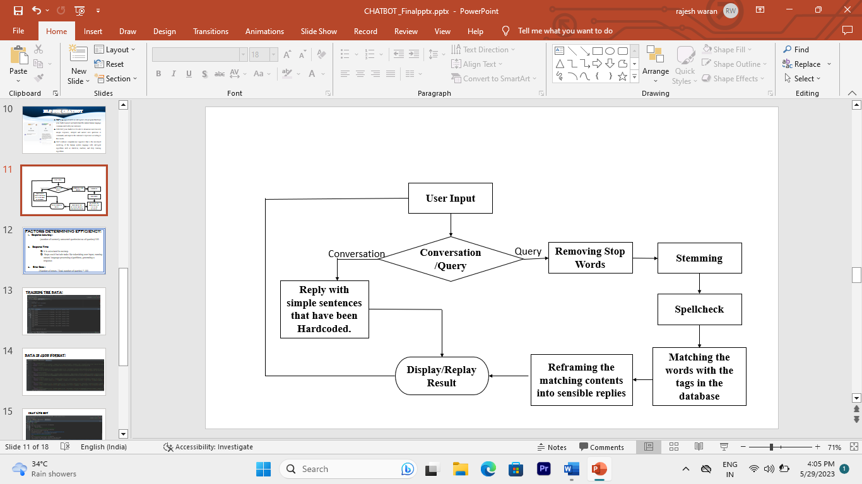

Figure:3.2

**CHAPTER-4**

**REQUIREMENT SPECIFICATION**

* 1. **INTRODUCTION:**

The requirement for this experiment requires software requirements that are illustrated below

* 1. **SOFTWARE REQUIREMENTS**

|  |  |
| --- | --- |
| Operating System : | Windows 10 |
| IDE : | Pycharm , Vscode |
| Language : | Python |

* 1. **APPLICATION:**

This project main application is building a college chatbot application using artificial intelligence designed to enhance the student experience and provide comprehensive support . The chatbot leverages Natural Language Processing(NLP) and machine learning algorithms to understand user queries and provide accurate and personalized responses.

# CHAPTER 5

## METHODOLOGY

* 1. **LIST OF MODULES:**
     + Data collection
     + Data preprocessing
     + Design Conversation Flow
     + Develop NLP Models
     + Model Training
     + Intent Recognition and Entity Extraction:
     + Implement Dialog Management:
     + Integration and External Services
     + Testing and Validation

**5.1.1 Data Collection:**

Collect a dataset of user queries and their corresponding intents or responses. This dataset will be used for training and evaluating the chatbot's performance. Ensure the dataset is diverse, representative of real-world scenarios, and adequately covers the range of intents and user inputs.

**5.1.2 Data Preprocessing:**

Preprocess the collected data by cleaning and normalizing it. Remove any noise, irrelevant information, or personally identifiable information (PII). Tokenize the text, perform stemming or lemmatization, and handle any data-specific challenges.

**5.1.3 Design Conversation Flow:**

Define the conversation flow for the chatbot. Determine the possible user intents, map out the possible dialog paths, and design the structure of the conversation. This includes deciding on branching logic, handling multi-turn conversations, and considering error handling and fallback mechanisms.

**5.1.4 Develop NLP Models:**

Implement the NLP models and techniques necessary for the chatbot. This may involve using libraries such as NLTK, spaCy, or specialized NLP frameworks like Rasa. Train and fine-tune the models using the collected data to enable accurate intent recognition, entity extraction, and sentiment analysis.

**5.1.5 Model Training:**

Train the selected NLP model using the preprocessed dataset. Fine-tune the model parameters based on the specific chatbot objectives and performance metrics. Optimize the training process to achieve the desired accuracy and efficiency.

**5.1.6 Intent Recognition and Entity Extraction:**

Develop algorithms and techniques to recognize user intents and extract relevant entities from user input. This can involve using techniques like classification algorithms, rule-based approaches, or sequence labeling methods depending on the complexity of the intents and entities.

**5.1.7 Implement Dialog Management:**

Develop the logic and algorithms to manage the chatbot's dialog flow. This includes handling user input, recognizing intents, maintaining conversation context, and generating appropriate responses. Design error handling mechanisms to gracefully handle ambiguous or invalid input.

**5.1.8 Integration and External Services:**

If required, integrate the chatbot with external APIs, databases, or services to enhance its functionality. This could involve connecting to a weather API, accessing a product database, or integrating with a customer support ticketing system.

**5.1.9 Testing and Validation:**

Thoroughly test the chatbot to ensure its performance, accuracy, and reliability. Test various user scenarios, including expected and edge cases, to validate the chatbot's behavior. Monitor and iterate on the chatbot's performance, continuously refining and improving its responses and understanding.

## ALGORITHM:

**Natural Language Processing (NLP) Algorithms:**

**Tokenization:** Algorithms like word tokenization or regex-based tokenization can split text into individual tokens (words or phrases).

**Part-of-Speech (POS) Tagging:** Algorithms like the Hidden Markov Model (HMM) or the MaxEnt algorithm can assign grammatical tags to tokens.

**Named Entity Recognition (NER):** Algorithms like Conditional Random Fields (CRF) or Bidirectional LSTM-CRF models can identify and classify named entities in text.

**Sentiment Analysis:** Algorithms like Naive Bayes, Support Vector Machines (SVM), or Recurrent Neural Networks (RNN) can analyze and classify the sentiment expressed in text.

**Syntactic Parsing:** Algorithms like the CKY algorithm or Transition-based Parsing can analyze the grammatical structure of sentences.

## Neural Networks:

Deep learning models like Convolutional Neural Networks (CNN), Recurrent Neural Networks (RNN), or Transformer models can be trained to recognize intents from user input.

## STEPS INVOLVED IN TRAINING

**Train/Test Data Split:**

Split the preprocessed dataset into a training set and a testing set. The training set will be used to train the chatbot's models, while the testing set will be used to evaluate its performance. This split helps assess the model's generalization capabilities.

## Feature Extraction:

Extract relevant features from the training data to represent the user queries and responses. This can involve techniques like word embeddings (e.g., Word2Vec or GloVe) or sequence encoders (e.g., LSTM or Transformer models). The goal is to convert text into numerical representations that can be used by machine learning models.

## Model Selection:

Choose the appropriate model architecture for the chatbot. This can include sequence-to-sequence models (e.g., Encoder-Decoder, Transformer) or retrieval- based models (e.g., TF-IDF, word embeddings). Consider the nature of the conversation and the desired functionality of the chatbot**.**

**Hyperparameter Tuning:**

Fine-tune the model's hyperparameters to optimize its performance. Adjust parameters like learning rate, batch size, or network architecture to improve the model's accuracy and efficiency. Use techniques like grid search or random search to find the optimal combination of hyperparameters.

## CHAPTER 6

## RESULTS

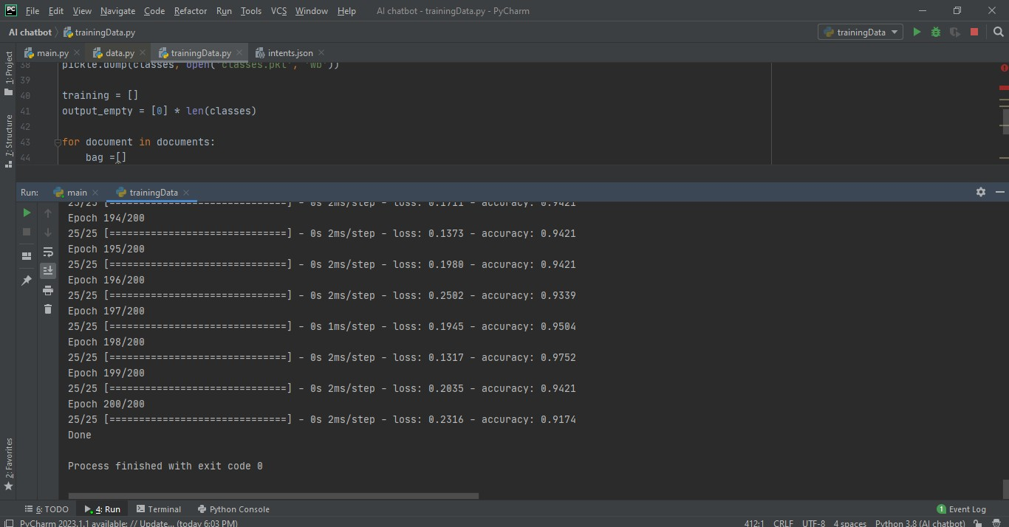

**FIGURE 6.1**

**Figure 6.1 shows the training of data. For the chatbot to understand the stored data it need to be trained.**

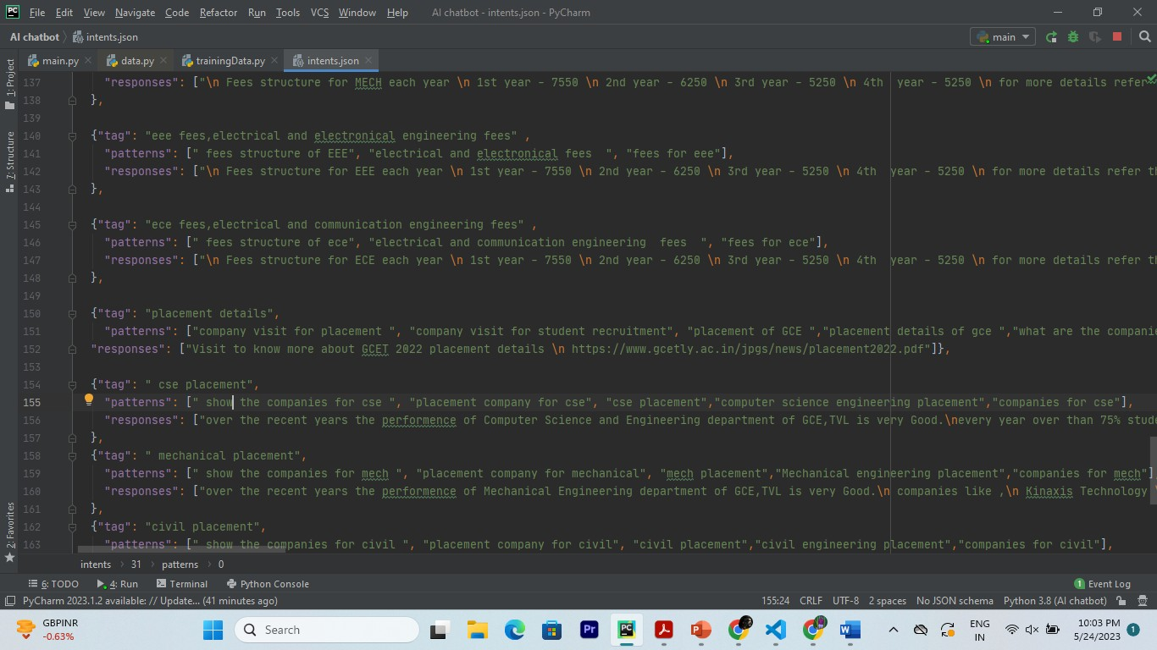

**FIGURE 6.2**

**Figure 6.2 The details about the college are collected from the college website and stored in JSON format.**

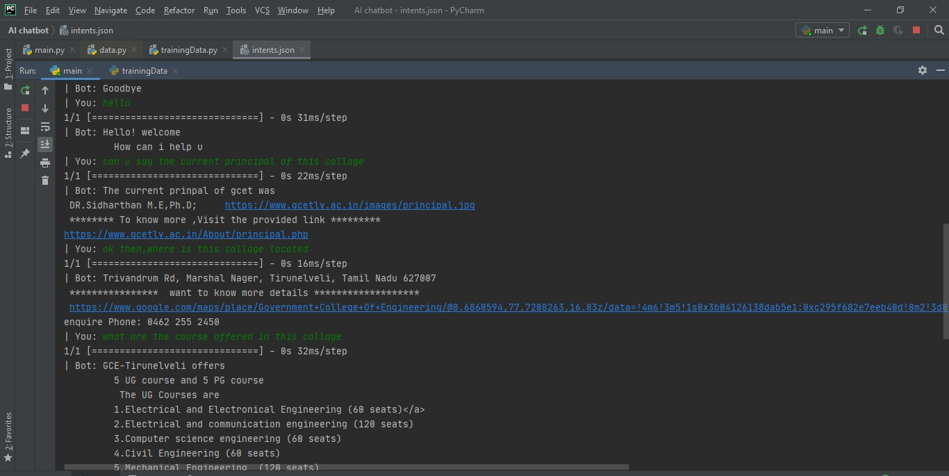

**Figure 6.3**



**Figure 6.4**

**The above figures 6.3 and 6.4 displays the chat between the user and the chatbot.**

**CHAPTER 7 CONCLUSION**

In conclusion, the development of an AI-powered chatbot for a college using NLP and implemented in Python offers significant benefits. The chatbot serves as a virtual assistant, enabling seamless communication and providing valuable information to students, faculty, and staff. By leveraging AI and NLP techniques, the chatbot can understand natural language queries, generate appropriate responses, and perform various tasks related to college operations and support.

The project follows a systematic methodology, including steps such as data collection, preprocessing, model training, evaluation, and deployment. Data collected from college-related conversations forms the basis for training the chatbot. The data is preprocessed to ensure accurate analysis, including tokenization, stemming, or lemmatization. Once trained, the chatbot can be deployed on various platforms such as websites, messaging apps, or mobile applications.

Implementing an AI-powered chatbot using NLP and Python fosters efficient communication, improves user experience, and enhances the overall college ecosystem. It offers a personalized and interactive interface, empowering students, faculty, and staff with quick access to information, support, and resources. The project contributes to the advancement of technology-driven solutions in the educational domain.

**CHAPTER 8**

**REFERENCES:**

A guide to Natural Langugage Processing, Available at

https://en.wikipedia.org/wiki/Natural_language_processing

[2] Chatbot definition, Available at https://medium.com/@mg/bot-is-a-

hilariously-over-simplified-buzzword-let-s-fix-that-

f1d63abb8ba7#:~:text=A%20chatterbot%20(also%20known%20as,via%

20auditory%20or%20textual%20methods.

[3] Introduction to Artificial Intelligence Markup Language, Available at

https://www.tutorialspoint.com/aiml/aiml_introduction.htm

[4] Prof.K.Bala, Mukesh Kumar, SayaliHulawale, SahilPandita,“Chat-Bot

For College Management System Using A.I” International Research

Journal of Engineering and Technology (IRJET) Volume: 04, Issue: 11,

Page no: 2030-2033| Nov 2017.

[5] Porter Stemmer Algorithm, Available at

http://snowball.tartarus.org/algorithms/porter/stemmer.html

[6] Guruswami Hiremath, AishwaryaHajare, PriyankaBhosale,

RasikaNanaware, Dr. K. S. Wagh, “Chatbot for education system”

International Journal of Advance Research, Ideas and Innovations in

Technology (IJARIIT) ISSN: 2454-132X, Volume: 4, Issue: 3, Page no:

37-43|2018.

[7] Amey Tiwari, Rahul Talekar, Prof.S.M.Patil, “College Information Chat

Bot System” International Journal of Engineering Research and General

Science (IJERGS) Volume: 5, Issue: 2, Page no: 131-137| March-April

2017.

[8] K. Jwala, G.N.V.G Sirisha, G.V. Padma Raju, “Developing a Chatbot

using Machine Learning” International Journal of Recent Technology

and Engineering (IJRTE) ISSN: 2277-3878, Volume: 8 Issue: 1S3, Page

no: 89-92| June 2019

A guide to Natural Langugage Processing, Available at

https://en.wikipedia.org/wiki/Natural_language_processing

[2] Chatbot definition, Available at https://medium.com/@mg/bot-is-a-

hilariously-over-simplified-buzzword-let-s-fix-that-

f1d63abb8ba7#:~:text=A%20chatterbot%20(also%20known%20as,via%

20auditory%20or%20textual%20methods.

[3] Introduction to Artificial Intelligence Markup Language, Available at

https://www.tutorialspoint.com/aiml/aiml_introduction.htm

[4] Prof.K.Bala, Mukesh Kumar, SayaliHulawale, SahilPandita,“Chat-Bot

For College Management System Using A.I” International Research

Journal of Engineering and Technology (IRJET) Volume: 04, Issue: 11,

Page no: 2030-2033| Nov 2017.

[5] Porter Stemmer Algorithm, Available at

http://snowball.tartarus.org/algorithms/porter/stemmer.html

[6] Guruswami Hiremath, AishwaryaHajare, PriyankaBhosale,

RasikaNanaware, Dr. K. S. Wagh, “Chatbot for education system”

International Journal of Advance Research, Ideas and Innovations in

Technology (IJARIIT) ISSN: 2454-132X, Volume: 4, Issue: 3, Page no:

37-43|2018.

[7] Amey Tiwari, Rahul Talekar, Prof.S.M.Patil, “College Information Chat

Bot System” International Journal of Engineering Research and General

Science (IJERGS) Volume: 5, Issue: 2, Page no: 131-137| March-April

2017.

[8] K. Jwala, G.N.V.G Sirisha, G.V. Padma Raju, “Developing a Chatbot

using Machine Learning” International Journal of Recent Technology

and Engineering (IJRTE) ISSN: 2277-3878, Volume: 8 Issue: 1S3, Page

no: 89-92| June 2019

A guide to Natural Langugage Processing, Available at

https://en.wikipedia.org/wiki/Natural_language_processing

[2] Chatbot definition, Available at https://medium.com/@mg/bot-is-a-

hilariously-over-simplified-buzzword-let-s-fix-that-

f1d63abb8ba7#:~:text=A%20chatterbot%20(also%20known%20as,via%

20auditory%20or%20textual%20methods.

[3] Introduction to Artificial Intelligence Markup Language, Available at

https://www.tutorialspoint.com/aiml/aiml_introduction.htm

[4] Prof.K.Bala, Mukesh Kumar, SayaliHulawale, SahilPandita,“Chat-Bot

For College Management System Using A.I” International Research

Journal of Engineering and Technology (IRJET) Volume: 04, Issue: 11,

Page no: 2030-2033| Nov 2017.

[5] Porter Stemmer Algorithm, Available at

http://snowball.tartarus.org/algorithms/porter/stemmer.html

[6] Guruswami Hiremath, AishwaryaHajare, PriyankaBhosale,

RasikaNanaware, Dr. K. S. Wagh, “Chatbot for education system”

International Journal of Advance Research, Ideas and Innovations in

Technology (IJARIIT) ISSN: 2454-132X, Volume: 4, Issue: 3, Page no:

37-43|2018.

[7] Amey Tiwari, Rahul Talekar, Prof.S.M.Patil, “College Information Chat

Bot System” International Journal of Engineering Research and General

Science (IJERGS) Volume: 5, Issue: 2, Page no: 131-137| March-April

2017.

[8] K. Jwala, G.N.V.G Sirisha, G.V. Padma Raju, “Developing a Chatbot

using Machine Learning” International Journal of Recent Technology

and Engineering (IJRTE) ISSN: 2277-3878, Volume: 8 Issue: 1S3, Page

no: 89-92| June 2019

[1] A guide to Natural Langugage Processing, Available at <https://en.wikipedia.org/wiki/Natural_language_processing>.

**[**2] Introduction to Artificial Intelligence Markup Language, Available at <https://www.tutorialspoint.com/aiml/aiml_introduction.htm>

[3] Prof.K.Bala, Mukesh Kumar, SayaliHulawale, SahilPandita,“Chat-Bot For College Management System Using A.I” International Research Journal of Engineering and Technology (IRJET) Volume: 04, Issue: 11, Page no: 2030-2033| Nov 2017.

[4] Guruswami Hiremath, AishwaryaHajare, PriyankaBhosale, RasikaNanaware, Dr. K. S. Wagh, “Chatbot for education system” International Journal of Advance Research, Ideas and Innovations in Technology (IJARIIT) ISSN: 2454-132X, Volume: 4, Issue: 3, Page no: 37-43|2018.

[5] Amey Tiwari, Rahul Talekar, Prof.S.M.Patil, “College Information Chat Bot System” International Journal of Engineering Research and General Science (IJERGS) Volume: 5, Issue: 2, Page no: 131-137| March-April 2017.

[6] Basics of Natural Language ToolKit, Avalilable at <https://www.nltk.org/>

[7] Fundamentals of Natural Language Processing - Tokenization, Lemmatization, Stemming and Sentence Segmentation, Available at <https://colab.research.google.com/github/dairai/notebooks/blob/master/_notebooks/2020-03-19> NLP_basics_tokenization_segmentation.ipynb#scrollTo=H7gQFbUxOQt b